Helsinki Committee
Request for Approval

A: Personal Data
Date: 2019 October 22
Name: Dr.Tarek Loubani | Residency: Canada
Institution: University of Western Ontario | Specialty: Emergency Medicine
Degree: Associate Professor, Medical Doctor | Place of work: London Health Sciences
Mobile: | Email: tarek@tarek.org

Date: 2019 October 22
Name: Dr. Mohammed Al Attar | Residency: Palestine -Gaza
Institution: Palestinian Civil Defense -Gaza | Specialty: Emergency Medicine
Degree: Emergency and disaster Medicine Consultant | Place of work: Palestinian Civil Defense
Mobile: 0598590516 | Email: dr.alattar102@gmail.com

B: Proposal Details
1. Title:
Prospective clinical trial comparing effectiveness of 3D printed and injection molded open source tourniquet against premium commercial tourniquets.

2. Objectives:
1. To compare a 3D printed open source tourniquet against the premium brand Combat Application Tourniquet (CAT).
2. To compare an injection-molded open source tourniquet against the premium brand Combat Application Tourniquet (CAT).
3. To compare a 3D printed open source tourniquet to an injection-molded open source tourniquet.

3. Methodology

3.1. Study design:
Unblinded prospective randomized controlled trial

3.2. Study population:
All trauma patients with life threatening external bleeding that can be manged by tourniquet application by the main ambulance service providers (PRCS-MOH-PCD and MMS) during the study period.

3.3. Expected date of data collection:
Upon approval of ethics (expected before 2020 January 1) until 2021 December 31

3.4. Data collection:
Questionnaire |  | Yes
Blood testing |  | No
Other tissues or specimen exam |  | No
Are you giving drugs? |  | No
Are you intending to perform surgical or physical procedures? |  | Yes
If yes, describe:
A tourniquet will be applied proximal to the area of injury causing exsanguination. The tourniquet will then be tightened according to internationally recognized procedures until bleeding is controlled on the patient.
Do you plan to get informed consent |  | No
If No, justify:
1. Administration of the tourniquet is a lifesaving procedure. Obtaining consent would delay care in a dangerous and life-threatening manner.
2. The 3D printed tourniquet is already in use in the field in Gaza today and has shown success so far.
3. The CAT is the current standard of care and would be used on patients in other countries.
4. The injection-molded tourniquet is based on the 3D printed tourniquet design and is expected to perform equivalently to the 3d printed tourniquet and the CAT.

If you have further details please add here:
No one should bleed to death. This is the main goal of Gaza's stop-bleeding campaign. The production of 3D-printed and injection-molded tourniquets in Gaza will ensure that tourniquets are available to all providers when needed, regardless of the blockade or other political factors.This research study seeks to confirm with research that the tourniquets used in Gaza for the past two years are at least equal in efficacy to premium brand tourniquets, including the Combat Application Tourniquet (CAT) commonly used by military forces around the world.

Defining the problem
Uncontrolled acute arterial bleeding (e.g., from a femoral artery) can kill a person in less than 5 minutes.‏‏ Most deaths by exsanguination are due to the inability of the injured person or bystanders to provide first aid pending professional assistance.
Traditional methods of bleeding control for life-threatening external bleeding make use of the tourniquet as a last resort rather than the first choice. This can lead to the loss of a a life-threatening or even fatal amount of blood.
The use of simple tools such as tourniquet in the first seconds of acute bleeding from limb injuries has been shown to have a six-fold reduction in exsanguination-related mortality as well as significant decreases in exsanguination-related morbidity. This is confirmed by several studies and the practical experience of military doctors treating wounded soldiers on the battlefield.
These studies also demonstrated that concerns about the medical complications of the tourniquet application are unfounded, as affected limbs can withstand complete cessation of blood perfusion for two hours without complications. This is confirmed by the use of tourniquets by orthopedic and plastic surgeons to stop limb perfusion intraoperatively without significant complications. This time is more than enough to transport the patient to the nearest specialized hospital under normal conditions.

International experiences
In 2015, widespread mass shootings and bombings in the United States and elsewhere led to the launch of the first national stop bleeding campaign in the United States. This initiative aimed at training the community to deal with life-threatening bleeding.
The American College of Surgeons (ACS) adopted the task of preparing the national campaign's training program. This program relies on the use of auxiliary tools to stop bleeding quickly and effectively, such as tourniquets and quick clot gauze.
The ACS adopted the Combat Application Tourniquet (CAT) as a key tool to stopping life-threatening bleeding from the limbs because of its ease and speed of use. The CAT is certified and licensed by the U.S. Food and Drug Administration (FDA) as a medical device.

Application in Gaza
After learning from the American experience, medical authorities in Gaza realized the importance of transferring this experience to the local context. A joint governmental-academic venture started training the local community on how to deal with massive external bleeding, especially as this community is exposed to regular attacks from Israeli forces. Some of these attacks use weapons that lead to serious injuries, especially In the limbs, that require rapid interventions to stop life-threatening bleeding.
Some emergency medicine and disaster experts in Gaza wanted to establish a similar program and launch a national campaign or initiative to train the provider and lay communities in techniques to stop deadly bleeding in quick and effective ways. The team tried to import the CAT from abroad, but Israeli authorities refused to permit entry of the devices into Gaza. This led the team to make all efforts to produce tourniquets locally to bypass this challenge.
Experts in medicine and engineering were consulted about producing and manufacturing a tourniquet that functions as well as the CAT using locally available resources. Using 3D printing and other manufacturing techniques, a usable prototype tourniquet was created.

Great March of Return 2018
With the start of the Great March of Return in 2018, health care providers observed the targeting of protesters in the lower and upper extremities by Israeli soldiers, which often led to severe and life-threatening bleeding. This made more urgent the need to train ambulance crews and volunteers to stop exsanguination and bleeding-related mortality and morbidity in an effective way.
Paramedics and first responders resorted to rudimentary methods using available resources to make improvised tourniquets. Unfortunately, these improvised tourniquets are not always effective. This forced the accelerated development and production of 3D printed tourniquets.
The engineering team managed to produce tourniquets for field use and conducted tests on quality, strength and durability of the tourniquet's components. Parts that failed were redesigned to avoid observed weaknesses in the previous versions.

Training and testing on trainees and volunteers
Groups of medics and volunteers who are involved in field rescues of injured victims in the GMR were trained on how to stop life-threatening bleeding in different ways, the most important of which is the use of the 3D printed tourniquets.
During the training, we tested the ability of 3D printed tourniquets to stop the circulation, confirmed by using a pulse oximeter to check the blood oxygen concentration in the distal limb before and after the placement of 3D printed tourniquets, which proved the ability of the tool to completely stop the perfusion in the tested limb.

Literature supporting tourniquet use
Studies and research emphasize the importance of using tourniquets as an essential option to stop life-threatening bleeding:
- http://www.combattourniquet.com/
Since its combat introduction by the U.S. Army in 2005, the Combat Application Tourniquet® (CAT)– a true one-handed tourniquet – has decreased the mortality rate due to extreme exsanguination by 85%. The U.S. Army Institute of Research deemed it to be 100% effective.
https://www.bleedingcontrol.org
BleedingControl.org is an initiative of the American College of Surgeons and the Hartford Consensus and contains diagrams, news, videos, and other resources contributed by a variety of other private and nonprofit partners to help prepare you in the event you are witness to one of these unspeakable events,
Massive bleeding from any cause, but particularly from an active shooter or explosive event where a response is delayed can result in death . Similar to how the general public learns and performs CPR, the public must learn proper bleeding control techniques, including how to use their hands, dressings, and tourniquets. Victims can quickly die from uncontrolled bleeding, within five to 10 minutes.

Military history of increasing survival: The U.S. military experience with tourniquets and hemostatic dressings in the Afghanistan and Iraq conflicts
The resurgence of tourniquet use in the U.S. military that originated from the Tactical Combat Casualty Care program is discussed as are the specific events that contributed to the expanded use of tourniquets in the military. Statistics regarding the decrease in preventable battlefield deaths in the from extremity hemorrhage are presented. The use of hemostatic dressings in the military is reviewed.
Hemorrhage control devices: Tourniquets and hemostatic dressings
This article draws from the military’s experience with tourniquet use to describe what type of trauma victims are appropriate for tourniquet use in a civilian setting. Teaching points about tourniquets are presented as are common mistakes regarding their use. The role of the Committee on Tactical Combat Casualty Care in recommending tourniquets and hemostatic dressings is reviewed.
https://www.journalacs.org/article/S1072-7515(18)30101-7/abstract
Civilian Prehospital Tourniquet Use Is Associated with Improved Survival in Patients with Peripheral Vascular Injury —published as an article in press by the Journal of the American College of Surgeons. Tourniquet use has been proven to reduce mortality on the battlefield. Although empirically transitioned to the civilian environment, data substantiating survival benefit attributable to civilian tourniquet use is lacking. We hypothesized that civilian prehospital tourniquet use is associated with reduced mortality in patients with peripheral vascular injuries.
https://www.facebook.com/StopTheBleedPalestine/?modal=admin_todo_tour
A local page covering the training project on techniques for stopping severe bleeding in the Gaza Strip. The goal is to train the Palestinian community in which the citizen takes the role of the immediate responder and intervenes to save the lives of people with life-threatening bleeding.

All the given information are TRUE | Signature    Mohammed Al Attar | Signature    Tarek Loubani

Some pictures from "Stop the Bleed" training courses in Gaza

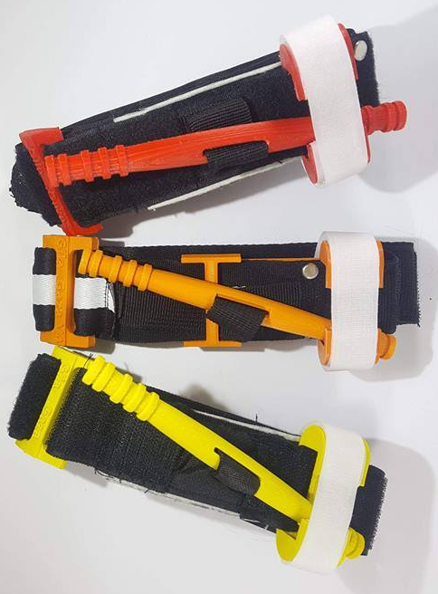
3d printed tourniquets
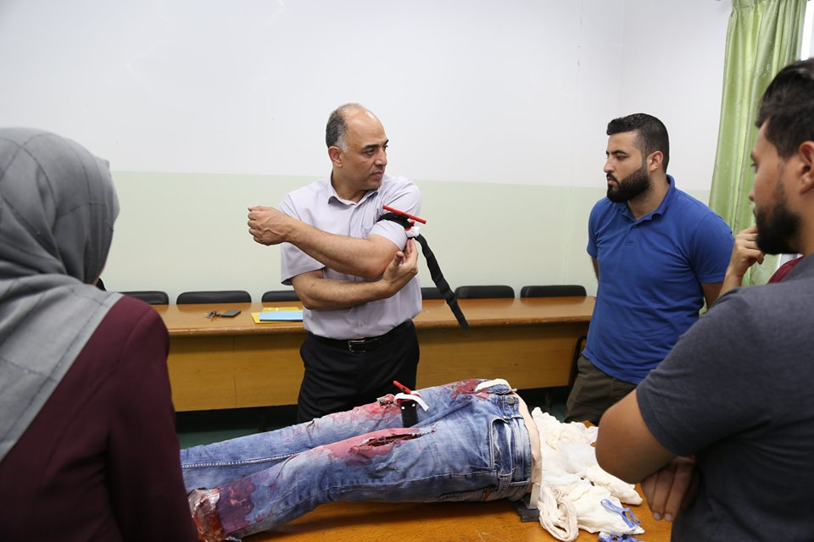

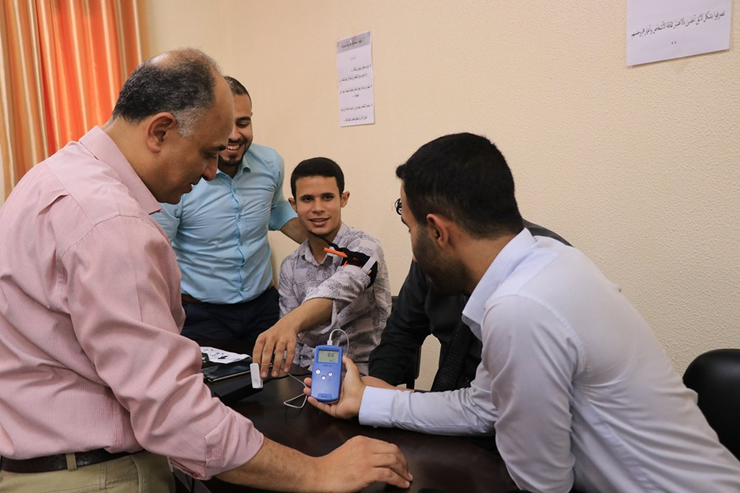
Testing the efficacy of 3d tourniquet by Pulse Oximeter on the trainees
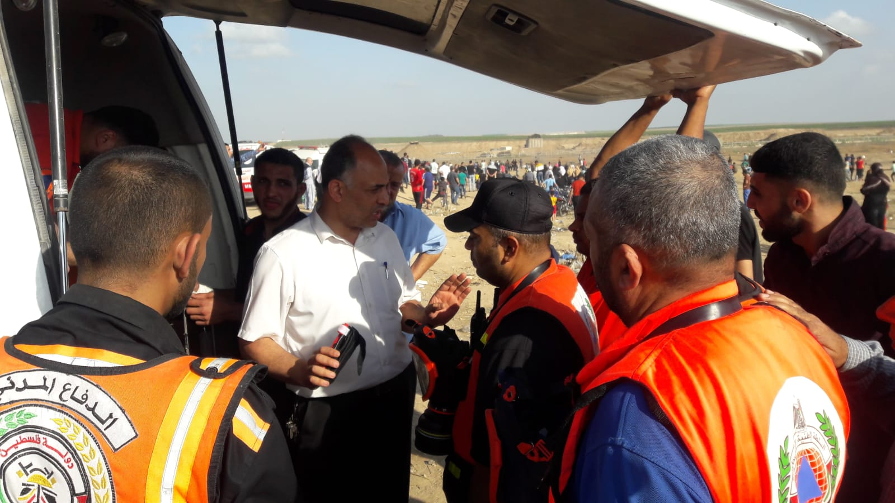
Field training of first responders and Medics in GMR

